
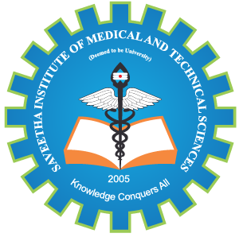
SIMATS ENGINEERING

Saveetha Institute of Medical and Technical Sciences
Chennai- 602105

Student Name: Janikaa Sri.R,Devi Shree S,Abinaya U Reg. No.: 192511092,192511149,192573023
Course Code: CSA1702 Slot: A
Course Name: Artificial Intelligence
Course Faculty: Dr.Bindu G
Project Title: Design and Development of a AI based Eye Tracking Virtual Keyboard for assistive communication.
Module-1: Eye Detection and Gesture Recognition
Module 2-AI-Based Virtual Keyboard and Typing System
Module 3-Communication and Accessibility Module
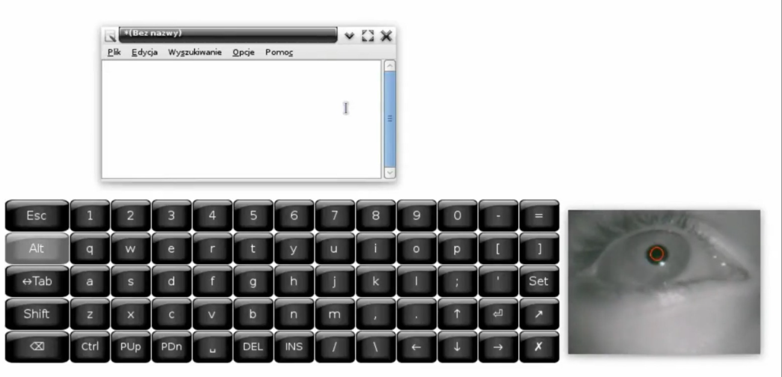

Project Description:
The AI-Based Eye Gesture Controlled Virtual Keyboard for Physically Challenged People is an assistive technology project designed to help individuals with severe physical disabilities communicate and interact with computers using only their eye movements and eye blinks. The system uses a standard webcam to capture the user's face and applies Artificial Intelligence (AI) and Computer Vision techniques to detect eye gaze direction and intentional blinks. Based on these eye gestures, a virtual keyboard displayed on the screen allows users to select letters, form words, and communicate without using a physical keyboard or mouse.
The project integrates technologies such as OpenCV, MediaPipe Face Mesh, Python, and Text-to-Speech (TTS) to provide a low-cost, real-time, and user-friendly communication solution. This system can significantly improve accessibility and independence for people with conditions such as paralysis, spinal cord injuries, muscular dystrophy, or ALS. The system enables physically challenged individuals to interact with a computer and communicate using only eye movements and blinks. It eliminates the need for a physical keyboard or mouse, providing a cost-effective, AI-powered accessibility solution that improves independence and quality of life.

Student Signature Guide Signature

